Special Promotion for Express $499 Customers During June 2012 -

Brightcove will customize a player for your website

Brightcove will customize a player for your website

Please help us create a video player that is styled to your brand by selecting from the customization options below. After you complete this and return it to your Account Manager, we will schedule a call with you to review your desired design.

Single Video or Playlist Player
Will you be using this player for a single video, or will you be creating a playlist (or several playlists) in Video Cloud Studio to be played back in this video player? Select your desired option.

Single Video Player
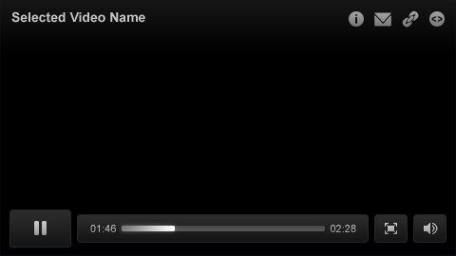

Playlist Player
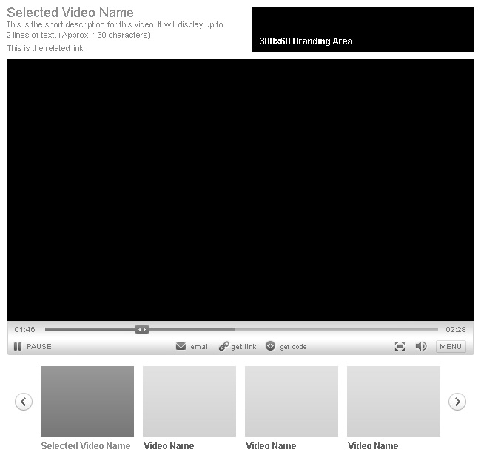

Multi-playlist Player
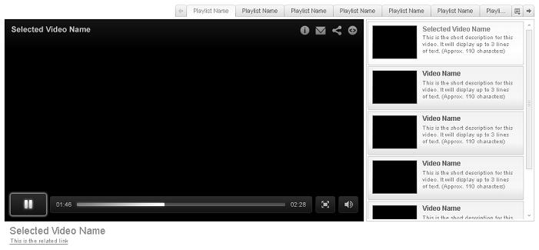

  - Player style – Each of our players is different. Which features would you prefer for your custom player?
Chromeless our lowest profile player features no player “chrome.” Player controls appear when the user hovers mouse over the player
Widescreen 16:9 aspect ratio
Standard 4:3 aspect ratio
For Playlist Players Only
  - Playlist Style- There are many ways to display your playlists. Please select the styles below that are most suitable to your brand.
Thumbnail Navigation playlist shows video title, short description and thumbnails
Video title navigation playlist shows video title and short description with no thumbnails
  - Playlist Location - Please tell us where you would like the playlist to be located in relation to the main video in your player. This should be determined by the design of the web page on which this video player will be located.
Right
Bottom

  - Player Size - Is this video player going to be a main feature of your web page, or will it support other content on the page. Please indicate the size that you would like this player to be.
Player Size: 770px wide

For a full list of player templates that are available for customizing, please see our Player Templates document.

Colors to Match Your Brand

Selecting colors that match your brand or website design will reinforce your image with your customers. If you have specific colors that you would like to use for your player, please provide us with the appropriate Hex codes. This is a 6-character code (a combination of letters and numbers) that represent the colors. (i.e. FF000 = Red). If you don’t have the Hex codes, you can find them from your web development team.

You can also change the colors in your player at any time through the Publishing module in Video Cloud Studio.

  - Color Choices
Preferred Color 1: 818285
Preferred Color 2: A8AAAD
Preferred Color 3: A81E28

Your Company Logo
Please indicate if you would like your company logo to be displayed as a watermark on your player.
Yes, I’d like my logo to be displayed as a watermark.
Download Logos here: http://www.control4.com/branding/files/Control4-Logos.zip

In order to continue to improve our product, we are interested to hear your feedback. Are there any other player customization options that are not listed above? Please let us know.
[open response]
Thank you for completing this form. Your Account Manager will be in touch with you within one business day to schedule a player customization consultation.

**For the color choices, Preferred color 3 is our corporate red and cannot change, however, we are flexible on the greys, Preferred Colors 1 and 2. Please let me know if there is any question about what we have selected: mklekas@control4.com.

